dsghdghshdsjkahStep: 01
Enter: www.dge.tn.gov.in

CLICK: Click Access to Online Portal for School and Educational office

CLICK: HSE FIRST YEAR MARCH 2019 NOMINAL ROLL VERIFICATION AND DOWNLOADING OF REPORTS

(OR)
Enter: tnschools.gov.in

CLICK: HSE FIRST YEAR MARCH 2019 NOMINAL ROLL VERIFICATION AND DOWNLOADING OF REPORTS

(OR)
Enter: emis.tnschools.gov.in

CLICK: HSE FIRST YEAR MARCH 2019 NOMINAL ROLL VERIFICATION AND DOWNLOADING OF REPORTS

Step: 02 - The following screen will appear
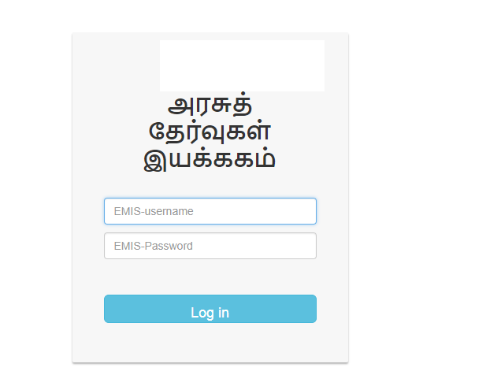
Enter: emis user ID and password . Press login button.

Step: 03 - School Profile 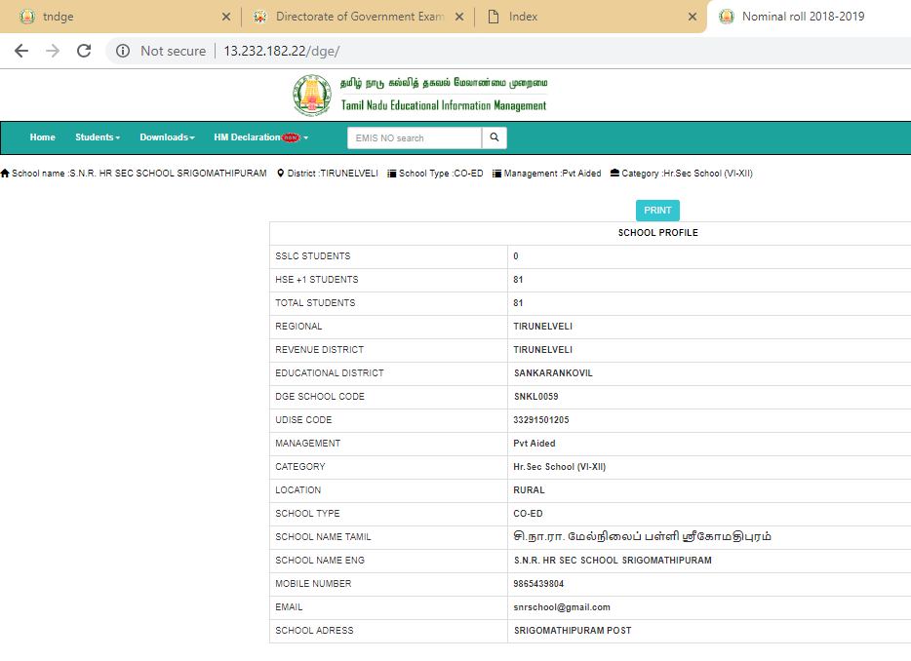
Take Profile printout and note down the new School code allotted by DGE.

Step: 04
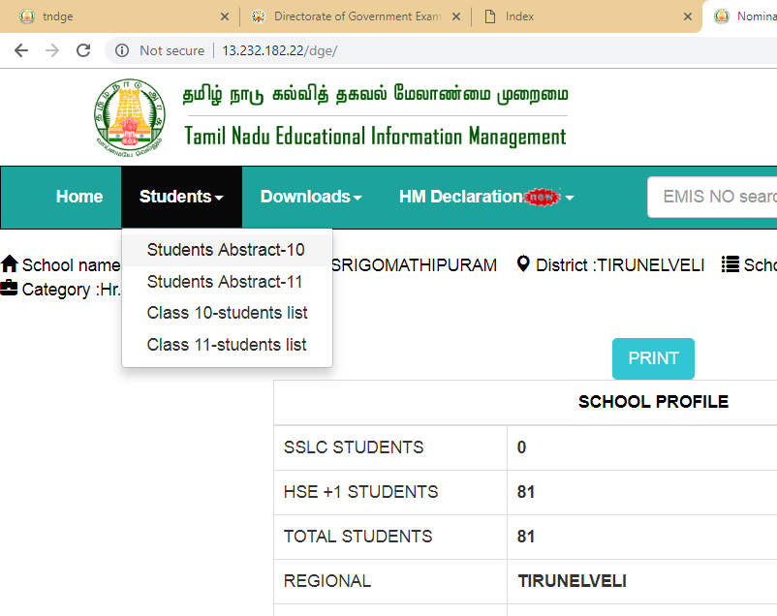
click: Students Link
click : Students Abstract - 11

Step: 05 - Group wise student summary
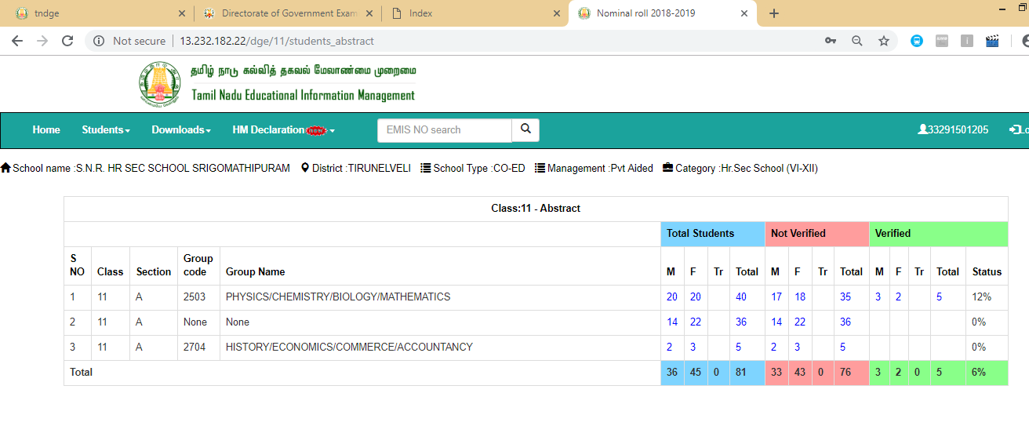
Student list will be displayed groupwise
To Verify Student Information

V
Step: 06 -
click here to verify student list
Step: 07
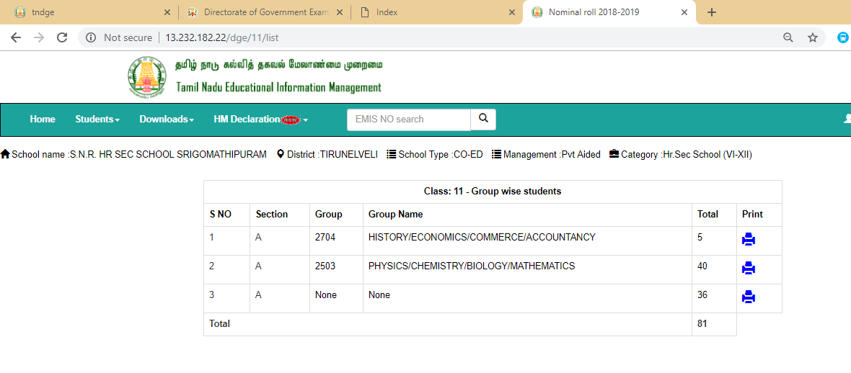
click on Group Name to verify candidate details
Student s Who have not been allotted the Group Code will come under none. Click here and allot group code for each Student and verify details.
click here and take print group wise candidates’ Declaration form with filled particulars and get signature from student , parents, Class Teacher and Principal/HM.

Candidate's Declaration Form
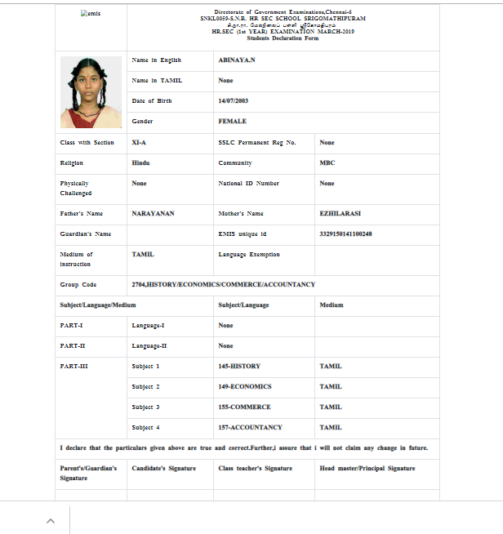

Step: 08 - to verify Student Particulars
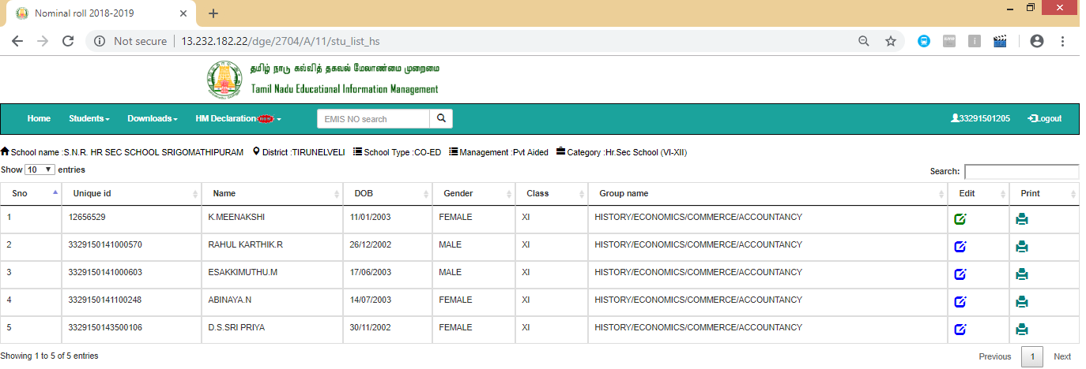
To Verify student’s particulars click here
click here to take a print of Student’s Declaration form

Important Note: Each and every Student’s particulars must be verified.

Step: 09 - Update Student Information
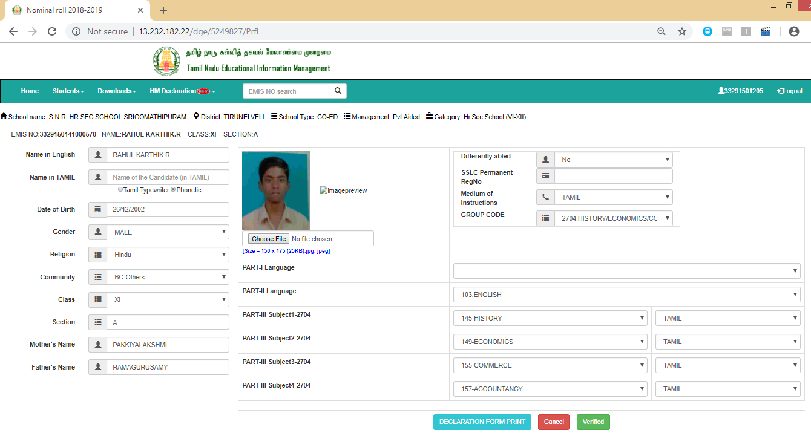
Enter the Name of Candidate in Tamil Version, if not updated earlier in emis portal
Enter SSLC Permanent Register Number
Select Part -I Language
click here for any changes to be made in medium,
Click here for any updation of photo

Step: 10 - To update Language Exemption for PH Candidate
Click Here PH Candidate Status
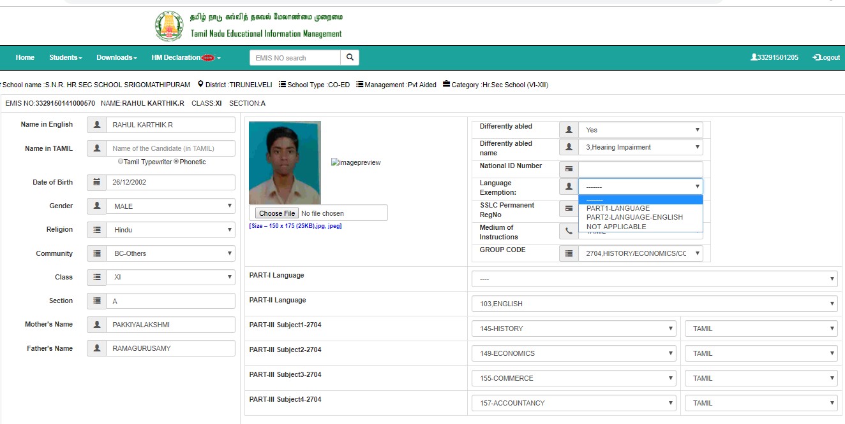
Select the Type of Disability
Select the language to avail Exemption

Step: 11 – HM Declaration
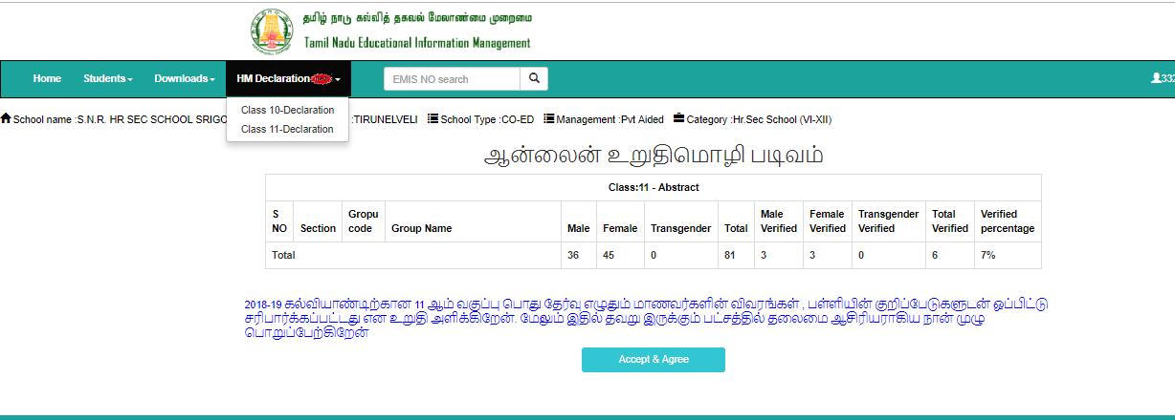
click HM Declaration and select Class -11 Declaration
After Verifying and satisfied with the particulars of each Student , The Principal / HM should click here.

Note: Once, the HeadMaster/ Principal has given DECLARATION, it will be treated as the Nominal Roll is completed by the respective school. Thereafter, Edit option will not be enabled.

